A. Create a timeline of the UX design activities that will take place during this project.

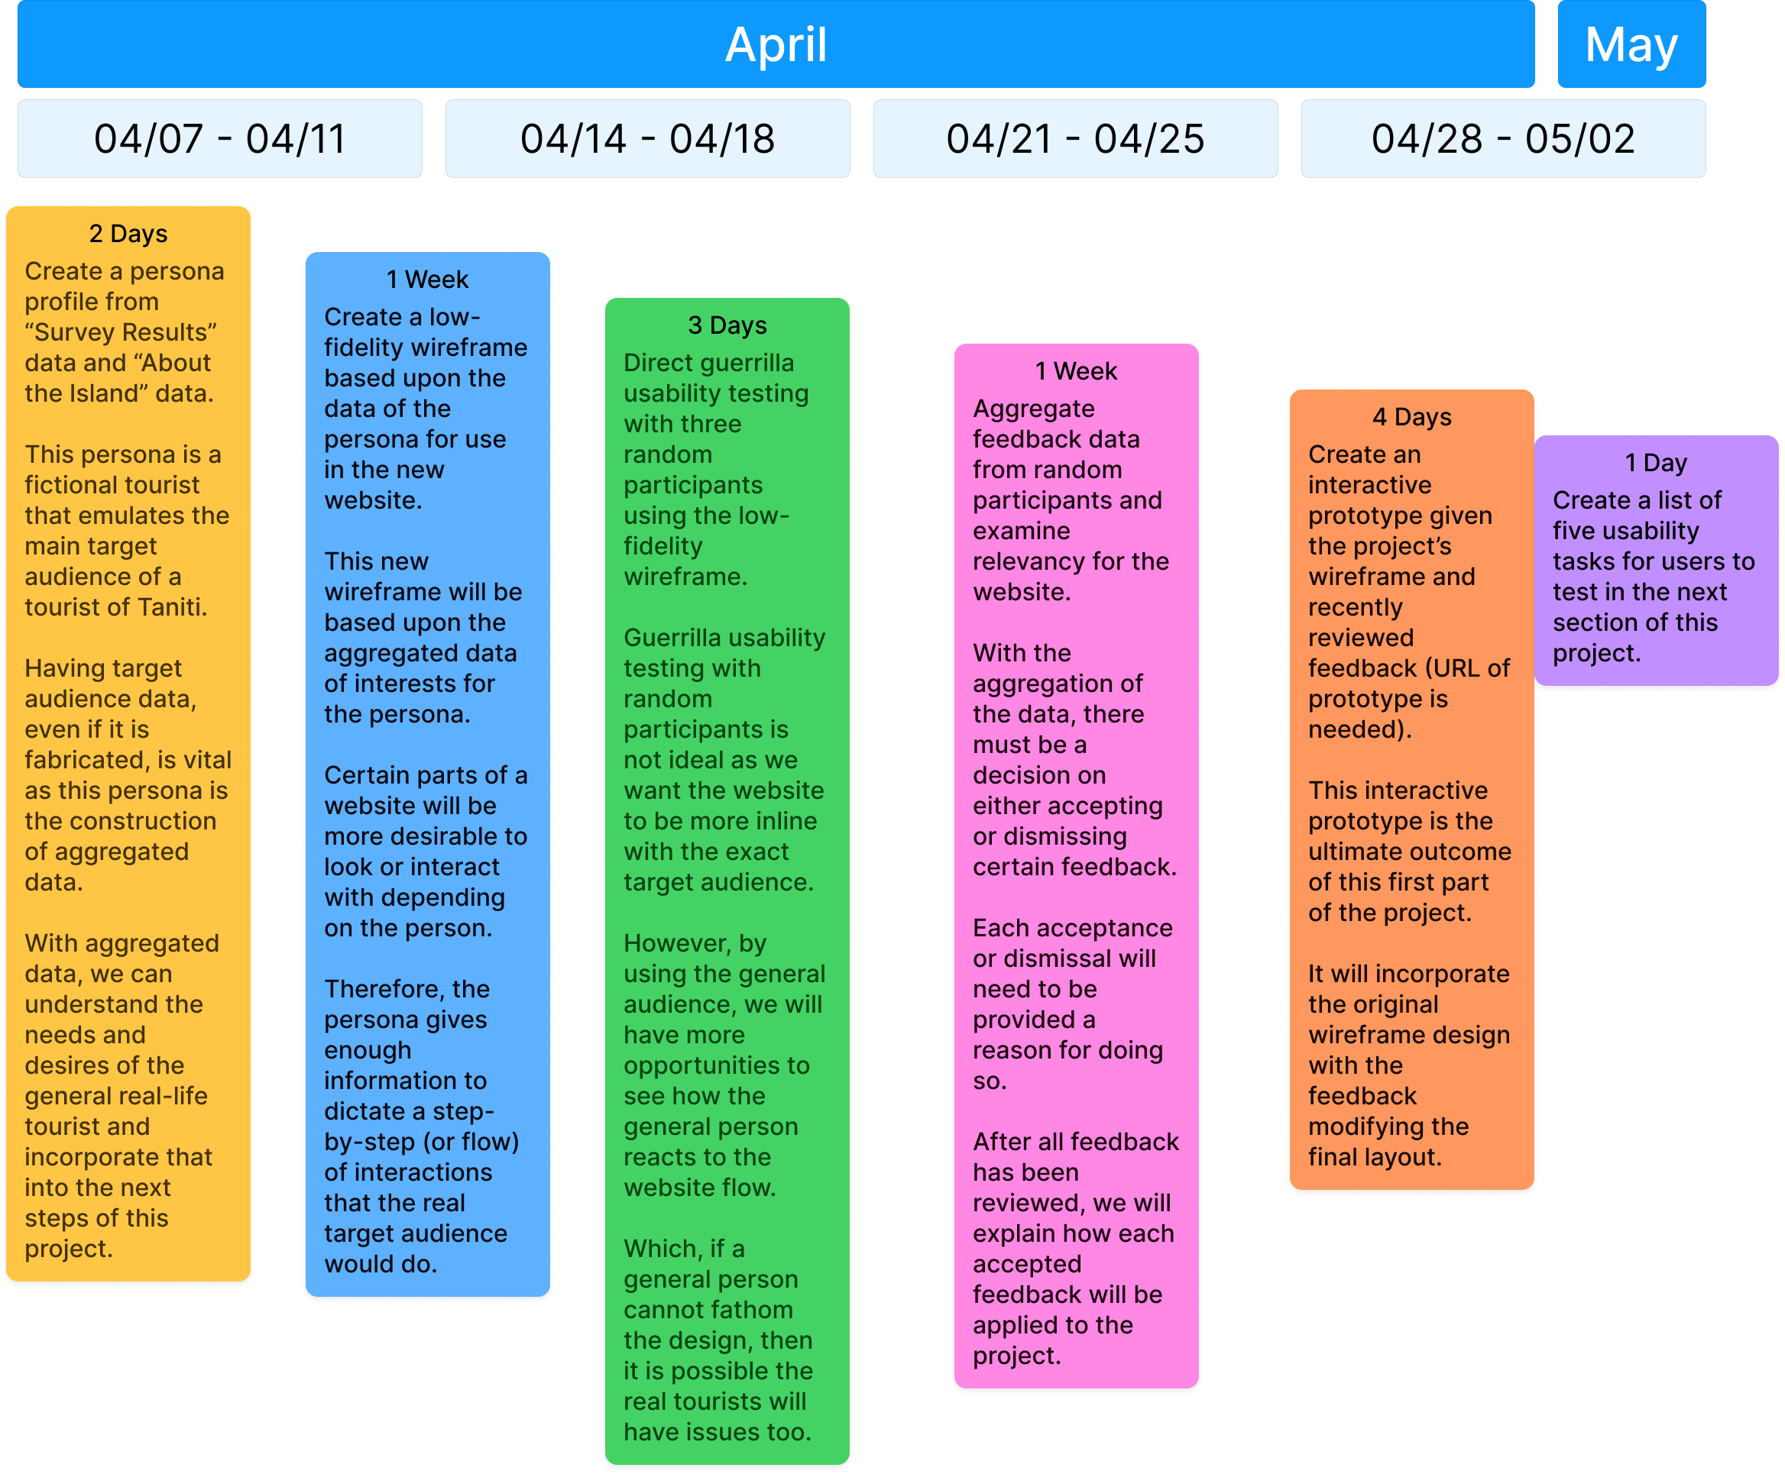

B. Create a persona profile based on the attached “Survey Results” and “About the Island” supporting documents.

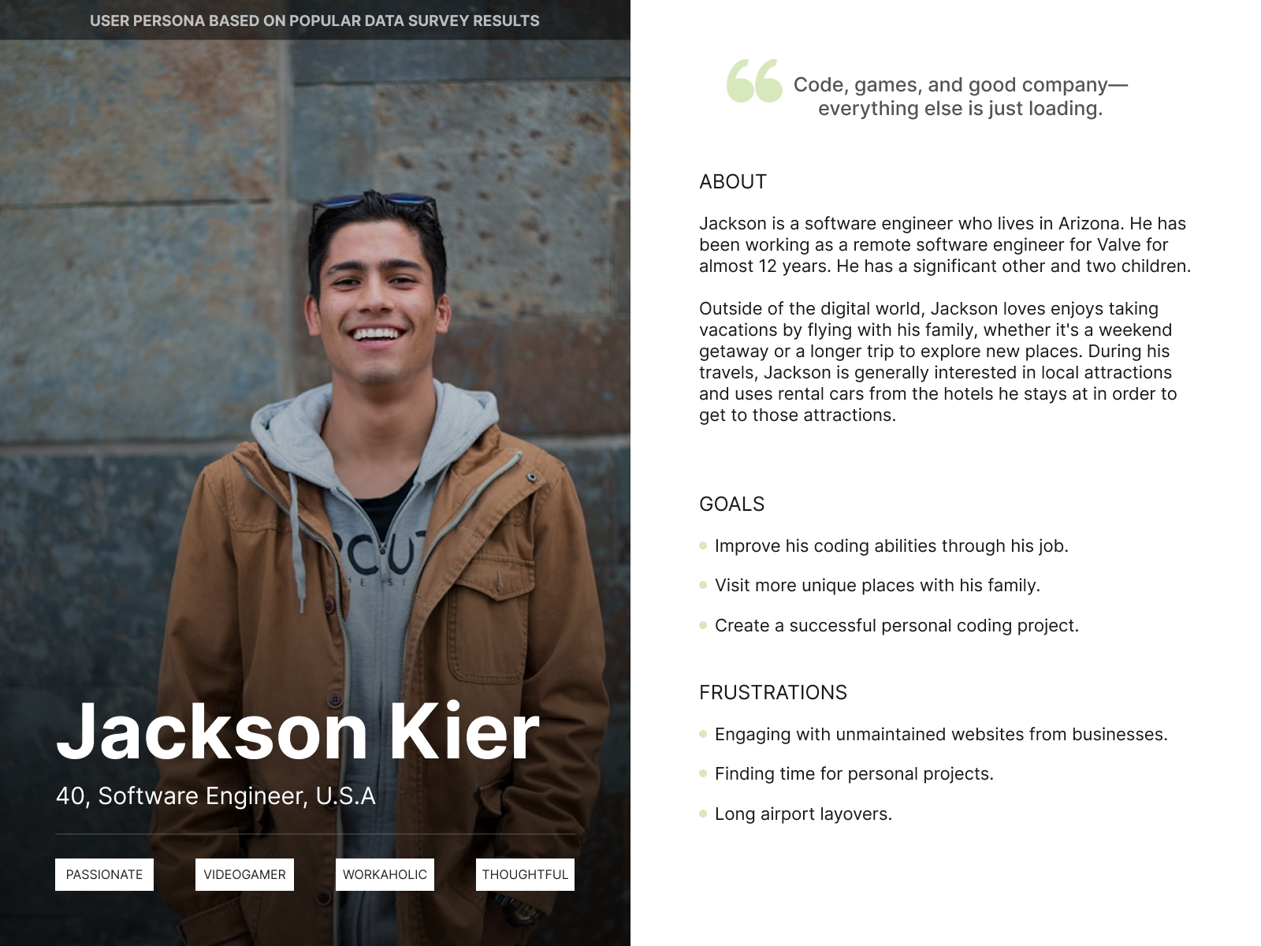

C. Create a low-fidelity wireframe showing the suggested flow of your new design for the Tanitian website.

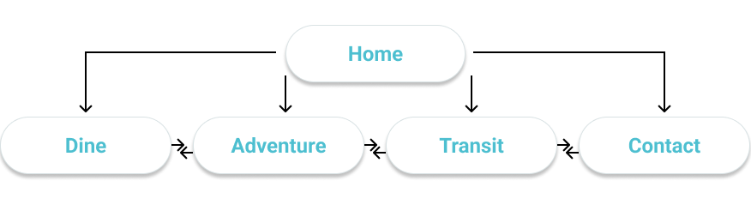

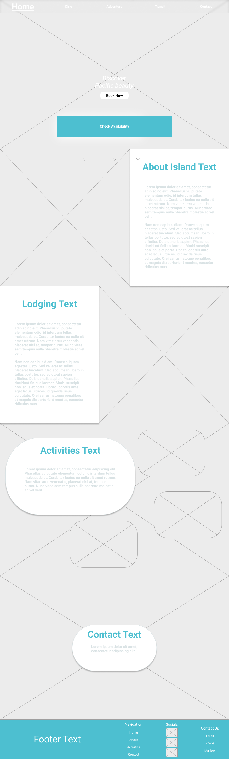

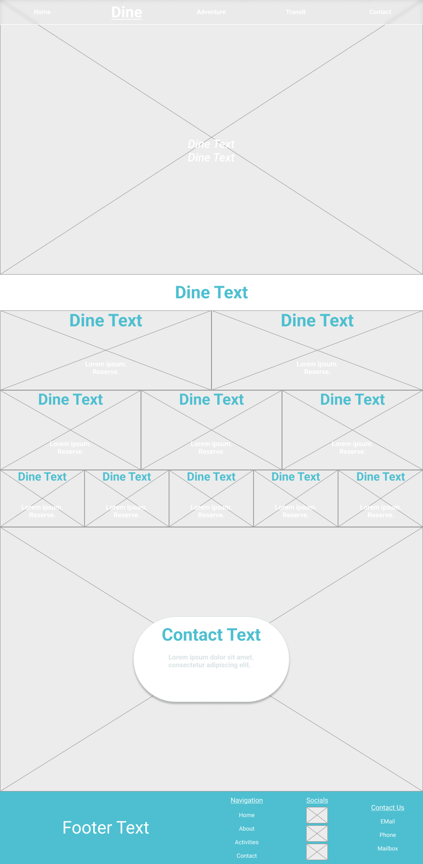
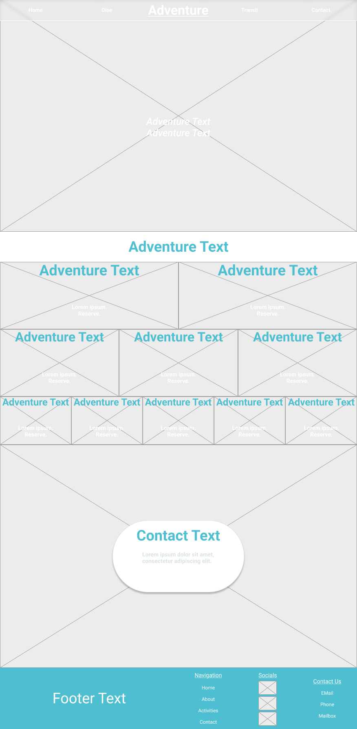

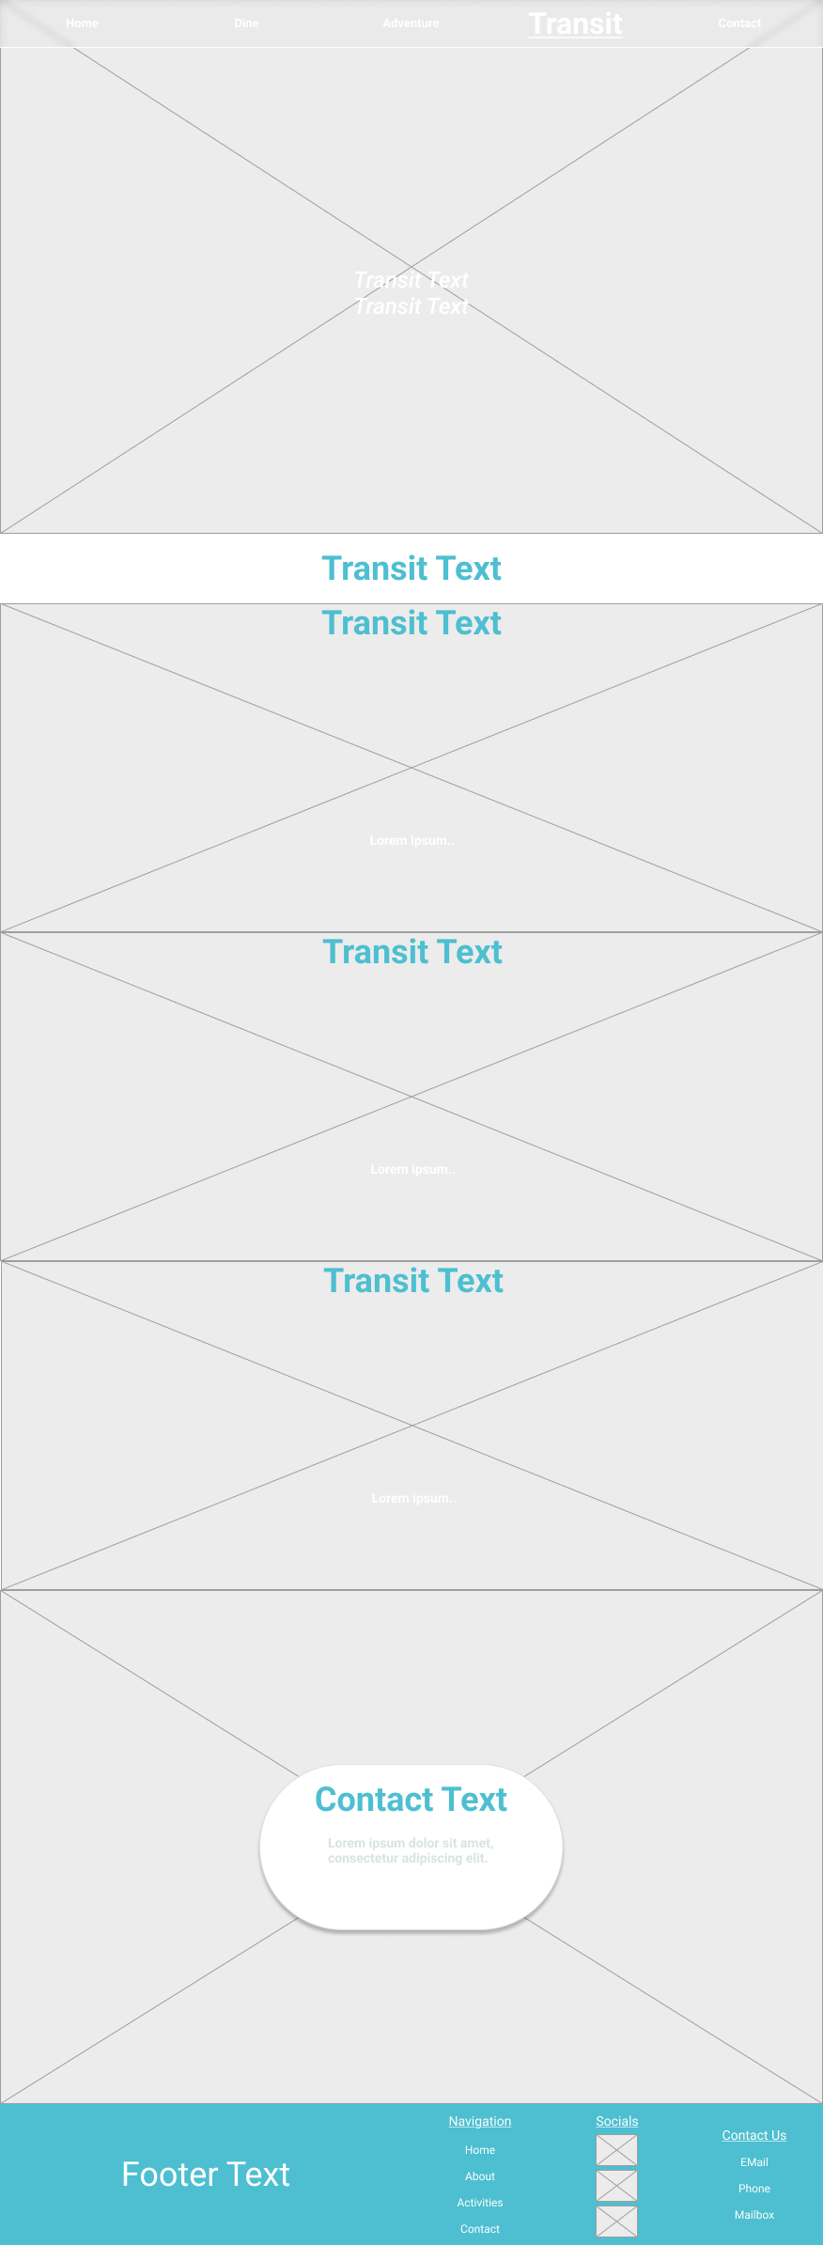

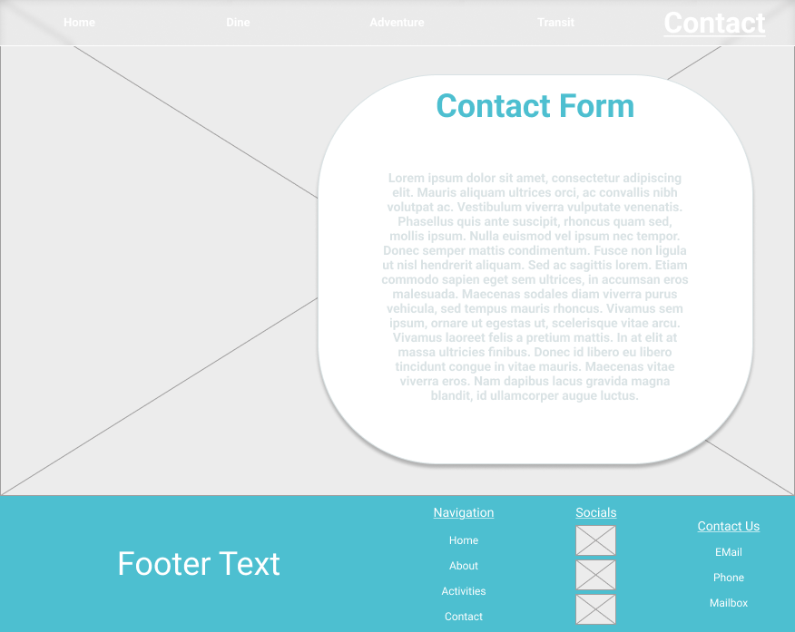

D. Conduct guerrilla usability testing with at least three user testers and then do the following:

1. Summarize the qualitative feedback you received, specifying which feedback is or is not actionable and relevant to your design.
Callum:
Qualitative feedback:
I love how clean and organized the layout is. The "Book Now" button is prominently placed in the home page which makes it easy to take action right away. The consistent contact section at the bottom of each page gives me confidence that I can reach out whenever I have questions.

Unactionable: User had no issues with the site and complemented design.
Ravi:
Qualitative feedback:
The hierarchical presentation of information works really well for me, especially in the Dine and Adventure sections. I appreciate how you've divided content into digestible chunks with clear headings. The availability widget on the homepage is exactly what I'd look for first when planning a trip.

Unactionable: User had no issues with the site and complemented design.
Elena:
Qualitative feedback:
Overall the design is clean, but I find the "Contact Form" section could use more structure. Right now it appears as just a large text block without clear form fields. Adding visible input areas for name, email, and message would make it more intuitive and increase the likelihood that I'd actually fill it out.

Actionable: The “Contact Form” can be changed to fit the remarks of the user. It is more of a text box than form fields.

2. Explain how you will incorporate the feedback you received to improve your design.
Of the three users, two had a flawless interaction with this low-fidelity wireframe. The third user had an issue with the “Contact Form” being without clear form fields. The “Contact Form” will be changed to be more label-centric than the text box currently given. This will improve upon readability and align with proper, modern form design.

E. Create an interactive prototype for the Tanitian website that reflects your wireframe design and incorporates the feedback you received during guerrilla testing. Your prototype must be submitted as a URL link.
https://www.figma.com/proto/jnyLhThFr4BnamKvM0hfDa/D479-Project-1---User-Experience?node-id=1072-30&p=f&t=hqFn1HUlhXofL5Rh-1&scaling=min-zoom&content-scaling=fixed&page-id=1067%3A29&starting-point-node-id=1072%3A30

F. List five objective usability tasks you want users to test in Task 2 for your prototype.
1. Find the name of one restaurant that serves Pan-Asian cuisine.
2. What are three entertainment options available in Merriton Landing?
3. What transportation options are available from the airport?
4. Where can you rent a bike on the island?
5. Identify two lodging options available on the island.

G. Acknowledge sources, using APA-formatted in-text citations and references, for content that is quoted, paraphrased, or summarized.

Abayasiri, P. (2023, September 3). Photo by pubs Abayasiri on unsplash. A view of the wing of an airplane flying over a body of water photo – Free Land Image on Unsplash. https://unsplash.com/photos/a-view-of-the-wing-of-an-airplane-flying-over-a-body-of-water-ettMYklM4Jg
Aicken, P. (2024, July 19). Photo by Phil Aicken on unsplash. photo – Free City Image on Unsplash. https://unsplash.com/photos/a-person-walking-down-a-narrow-street-with-mountains-in-the-background-SG-6aAEDdyU
Arancibia, G. (2018, May 4). Photo by Gabriel Arancibia on unsplash. Man in brown coat standing near concrete wall smiles photo – Free Portrait Image on Unsplash. https://unsplash.com/photos/man-in-brown-coat-standing-near-concrete-wall-smiles-wYvCXc-xUTg
Ballesteros, V. (2022, October 4). Photo by Victoria Ballesteros on unsplash. A person in scuba gear under water photo – Free Beach Image on Unsplash. https://unsplash.com/photos/a-person-in-scuba-gear-under-water-xsTqMVvStMA
Cadusseau, J. (2022, March 4). Photo by Jules Cadusseau on unsplash. A group of people sitting at wooden tables photo – Free Food Image on Unsplash. https://unsplash.com/photos/a-group-of-people-sitting-at-wooden-tables-r9VonMzYwzA
Camp, Z. (2022, January 17). Photo by Zach Camp on unsplash. A person writing on a piece of paper on a table photo – Free Coffee Image on Unsplash. https://unsplash.com/photos/a-person-writing-on-a-piece-of-paper-on-a-table-S4YNfBXYLVM
Chapple, G. (2019, August 6). Photo by Geri Chapple on unsplash. Yellow and white wooden cottage photo – Free Beach Image on Unsplash. https://unsplash.com/photos/yellow-and-white-wooden-cottage-rOSnVJPVhXE
Charit, K. (2023, April 12). Photo by Kevin Charit on unsplash. A restaurant with wooden tables and chairs photo – Free Building Image on Unsplash. https://unsplash.com/photos/a-restaurant-with-wooden-tables-and-chairs-UbmH18LwF98
Datingscout. (2022, February 3). Photo by Datingscout on unsplash. An outdoor dining area with tables and chairs photo – Free Restaurant Image on Unsplash. https://unsplash.com/photos/an-outdoor-dining-area-with-tables-and-chairs-9S_9IVeEzrU
Datt, V. (2019, October 13). Photo by Vijesh Datt on unsplash. Woman jumping on field photo – Free Human Image on Unsplash. https://unsplash.com/photos/woman-jumping-on-field-L19Q8n6rajg
Doyle, P. R. (2018, December 21). Photo by Patrick Robert Doyle on unsplash. Man laying on seashore photo – Free Beach Image on Unsplash. https://unsplash.com/photos/man-laying-on-seashore-jDR6xx0Sxqc
Dragunas, P. (2018, June 28). Photo by Paulius Dragunas on unsplash. Time lapse photography of multi-step waterfalls photo – Free Forest Image on Unsplash. https://unsplash.com/photos/time-lapse-photography-of-multi-step-waterfalls-cIxcxnwsnoI
Engelman, S. (2022, April 28). Photo by Scott Engelman on unsplash. A person walking through a forest photo – Free Forest Image on Unsplash. https://unsplash.com/photos/a-person-walking-through-a-forest-QXQwnU0A1Ww
File:applemaps logo.png. Wikimedia Commons. (n.d.). https://commons.wikimedia.org/wiki/File:AppleMaps_logo.png
File:facebook logo.png. FreePNGLogo. (n.d.). https://freepnglogo.com/facebook-logo-png-image
File:instagram icon.png. Wikimedia Commons. (n.d.). https://commons.wikimedia.org/wiki/File:Instagram_icon.png
Gallegos, C. (2020, December 26). Photo by Cassie Gallegos on unsplash. White table and chairs near green palm tree during daytime photo – Free Beach Image on Unsplash. https://unsplash.com/photos/white-table-and-chairs-near-green-palm-tree-during-daytime--I9QvRBsvP0
Haartman, M. von. (2025, April 1). Photo by Meg von Haartman on unsplash. photo – Free Volcano Image on Unsplash. https://unsplash.com/photos/person-poses-for-a-photo-on-a-mountain-ridge-82BaIgqosDI
Horner, C. (2018, May 4). Photo by Casey Horner on unsplash. Aerial photography of body of water photo – Free Wallpaper Image on Unsplash. https://unsplash.com/photos/aerial-photography-of-body-of-water-pm3PyXxRTvY
Isaacson, H. (2021, May 15). Photo by Hans Isaacson on unsplash. Boy in swimming goggles in water photo – Free Man Image on Unsplash. https://unsplash.com/photos/boy-in-swimming-goggles-in-water-BHoYdZYtuLg
Joe. (2023, November 19). Photo by Joe on unsplash. A blurry photo of a person bowling down a bowling alley photo – Free Man Image on Unsplash. https://unsplash.com/photos/a-blurry-photo-of-a-person-bowling-down-a-bowling-alley-1JI-pa93Ub0
Kazal, A. (2020, April 25). Photo by Ali Kazal on unsplash. Sliced orange fruits on green ceramic plate photo – Free Forest Image on Unsplash. https://unsplash.com/photos/sliced-orange-fruits-on-green-ceramic-plate-Jmgt9R3x5L4
Kumar, M. (2021, July 1). Photo by Mohit Kumar on unsplash. Aerial view of city buildings during night time photo – Free Building Image on Unsplash. https://unsplash.com/photos/aerial-view-of-city-buildings-during-night-time-Q-tzZuNU-XI
Lapyrin, I. (2021, February 13). Photo by Ivan Lapyrin on unsplash. Man in black zip up jacket sitting beside table with food photo – Free Food Image on Unsplash. https://unsplash.com/photos/man-in-black-zip-up-jacket-sitting-beside-table-with-food-guZdHo-izHc
Ljamin, A. (2019, July 29). Photo by Alex Ljamin on unsplash. Brown hanging bridge photo – Free Land Image on Unsplash. https://unsplash.com/photos/brown-hanging-bridge-44az6StHdrc
Manikoth, M. (2022, December 2). Photo by manas manikoth on unsplash. A man fishing on a lake photo – Free Man Image on Unsplash. https://unsplash.com/photos/a-man-fishing-on-a-lake--fu6IDGa_8I
Naseri, N. (2023, February 15). Photo by Nima Naseri on unsplash. A white plate topped with fish and vegetables photo – Free Food Image on Unsplash. https://unsplash.com/photos/a-white-plate-topped-with-fish-and-vegetables-RAUGKcReU8A
Nickson, R. (2019, May 19). Photo by Roberto Nickson on unsplash. Woman on kayak photo – Free Beach Image on Unsplash. https://unsplash.com/photos/woman-on-kayak-qxD1jo7KW70
Otterloo, S. (2023, May 11). Photo by Sieuwert Otterloo on unsplash. A view of a mountain through the trees photo – Free Land Image on Unsplash. https://unsplash.com/photos/a-view-of-a-mountain-through-the-trees-WLt_v_mrnD4
Oulashin, S. (2017, October 9). Photo by Sean Oulashin on unsplash. Seashore during golden hour photo – Free Wallpaper Image on Unsplash. https://unsplash.com/photos/seashore-during-golden-hour-KMn4VEeEPR8
Pradana, A. R. (2023, March 4). Photo by Aldrin Rachman Pradana on unsplash. A white plate topped with rice and meat photo – Free Food Image on Unsplash. https://unsplash.com/photos/a-white-plate-topped-with-rice-and-meat-B_1GyWCsc1s
Richard, G. (2019, June 30). Photo by Gerard Richard on unsplash. Meat with vegetables on plate photo – Free Food Image on Unsplash. https://unsplash.com/photos/meat-with-vegetables-on-plate-WPOkLDS1uBE
Romano, F. (2024, May 22). Photo by Fabio Romano on unsplash. A group of people riding on top of a bus photo – Free Car Image on Unsplash. https://unsplash.com/photos/a-group-of-people-riding-on-top-of-a-bus-zEsthqdujag
Samuil, Y. (2024, May 30). Photo by Yousef Samuil on unsplash. A hamburger and french fries on a wooden plate photo – Free Food Image on Unsplash. https://unsplash.com/photos/a-hamburger-and-french-fries-on-a-wooden-plate-pDxUJ2fk7Ds
Spring, S. (2023, January 4). Photo by Simon Spring on unsplash. A tropical beach with palm trees and clear water photo – Free Beach Image on Unsplash. https://unsplash.com/photos/a-tropical-beach-with-palm-trees-and-clear-water-BJ-FvNGCfEY
Urbancek, N. (2020, February 27). Photo by Nusa Urbancek on unsplash. Brown concrete building under blue sky during daytime photo – Free Building Image on Unsplash. https://unsplash.com/photos/brown-concrete-building-under-blue-sky-during-daytime-N7xFORdWulw
Vaga, E. (2022, December 18). Photo by Ernests Vaga on unsplash. An aerial view of a resort on an island photo – Free Land Image on Unsplash. https://unsplash.com/photos/an-aerial-view-of-a-resort-on-an-island-AT44jiruZI4
Vaga, E. (2022a, December 18). Photo by Ernests Vaga on unsplash. An aerial view of a resort in the ocean photo – Free Building Image on Unsplash. https://unsplash.com/photos/an-aerial-view-of-a-resort-in-the-ocean-wvgN8kF099A
Yana. (2021, April 4). Photo by Yana on unsplash. Person holding white ceramic mug photo – Free Food Image on Unsplash. https://unsplash.com/photos/person-holding-white-ceramic-mug-h8vQo-rgpKo

